**Qualcomm Flash Process**

1. **Preparation:**
2. Driver file
3. Flash tool file
4. OS file
5. PC (Windows 7 or windows 10，The PC must running on **pro version** or **Enterprise version** of windows)
6. **Operation Steps**
7. Enter test mode from PC end
8. Install USB download driver
9. Install QPST
10. Reflash the OS

Step 1: Enter test mode from PC end

1): input the ‘**CMD**’ in the red box and running as administrator

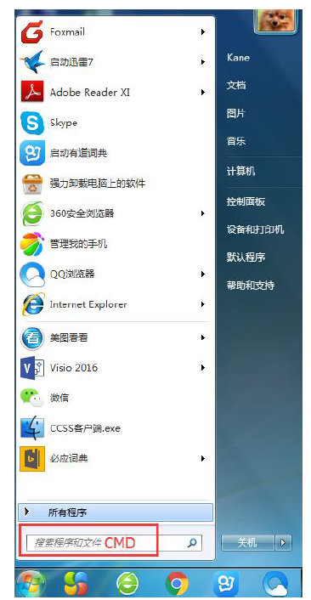

2): input the ‘**bcdedit/set testsigning on**’ in the dialog box, click enter

a)

If shows successfully, then it means PC already enters into test mode

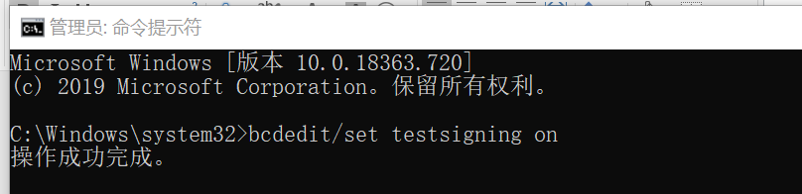

Next restart the computer

There shall be watermark in the bottom right corner of your PC

And continue next step (Step 2) - Install USB download driver

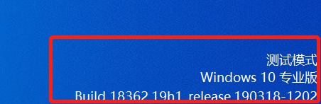

b)

If shows error like, *setting error: element data, unable to modify or delete*

Then Firstly need to **disable secure boot**, then go back to step 1 till watermark of [Test mode] appears.

(About how to **disable secure boot**, the action differentiates depends on different version and different brand of the computers used.

Suggest to google how to **disable secure boot )**

Step 2: Install USB download driver

Click the setup.exe in the [USB Download driver] folder, click next until finish

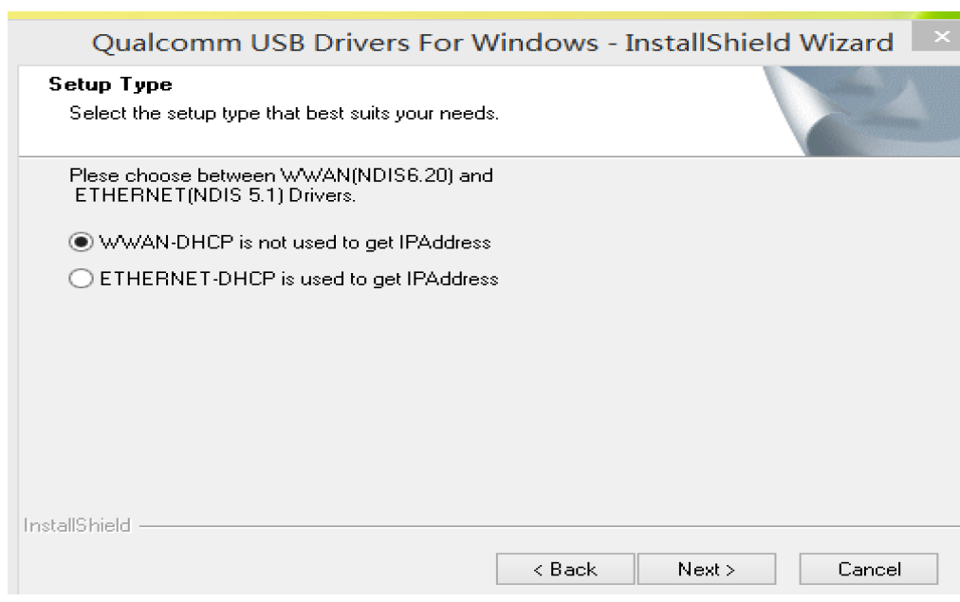

Step 3: Install QPST

Click QPST.2.7.476.exe in the folder of **[**qpst.win.2.7_installer_00476.6**]** to install it.

C:\Users\erst\AppData\Local\Temp\1585731675(1).png

Step 4: Reflash the OS

1. Find ‘QFIL’ and click to open it 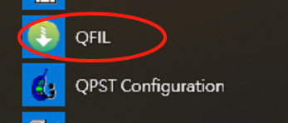
2. Device to enter reflash mode:

For Android 6, to enter reflash mode: power off firstly, then click the 3 buttons at the same time:

Power + ptt + scan button (at the left side)

For Android 9, to enter reflash mode: power off firstly, then click the 3 buttons at the same time :

Volume(+/-) + power

1. Connect the device to PC, the port will show up in QFIL.

Then follow below:

1. Select ‘Flat Build’

2, 3: need to select program file from the latest OS folder accordingly.

4: click download, if shows successful, then done.

